- Give four advantages and four disadvantages of ring topology.
Answer:
Advantages:
- The length of cabling required is realatively small.
- It doesn’t suffers from collisions.
- It is easy for installation.
- It is not very expensive(medium expense).
Disadvatages:
- It suffers from latency(delay at start).
- It has two single point of failure on ring and token.
- Difficult to identify and isolate faults.
- Difficult to add or remove a node.

- What is a protocol?
Answer:
The set of rules to be followed to fulfil the purpose is called protocol. For e.g. FTP File Transfer Protocol means the set of rules required to transfer files.

- What are the advantages of Bus topology for a LAN?
Answer:

- It has an ease of installation.
- It is cheap.
- Short cabling requirements.
- Better in terms of scalability.

- What are the advantages of point-to-point over multipoint connectivity? And what are advantages of multipoint over point-to point connectivity?
Answer:
Advantages of point to point over multi-point
- The communications turns out to be faster as the line is dedicated.
- The data transmission is more secure.
Advantages of multipoint over point to point
- It is best suitable for broadcasting.
- As it may be shared among many users it turns out to be cheaper.

- Describe the star topology and point out its advantages (use a diagram).
Answer:

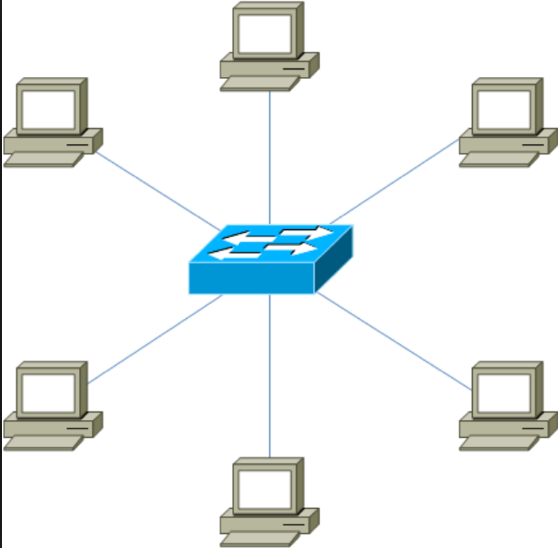

Star topology has a switch at its centre whereas older star topologies used to have hub. All the computers are connected to the central switch. They all have a single dedicated line to the switch. In case of failure of one the rest keeps on working as they all have dedicated line. Hence, it makes a lot easy to find a fault. It is very easy to scale adding extra switch will get the job done. The switch comes in different range and price depending upon the no of ports and speed. In terms of single point failure it suffers from it at the ports and if the switch fails it can lead to a big problem.
Advantages
- No latency.
- It is robust in case one fails others keep on working.
- Easy identification and isolation of faults.
- Scales very well (grows as a tree topology).
- It does not suffers from collisions.
- It is easy to reconfigure(add or remove a node)

- Which topology would you advice a company to use if it is interested in setting up a LAN. The intention is to use the LAN for exchanging videos between users. It is a requirement that it should be possible to plug in and out more computers to or from the network without any interruption to others. The company is also interested in keeping costs to minimum. Please give good reasons for you choices or options you offer the company and explain each reason.
Answer:
I would recommend a star topology as for exchanging videos we need a reliable speed which can be obtained here as all computers have dedicated line. For adding or removing a computer the cost/time required is less and provides no interruption to other computers.
The first hand cost maybe expensive than getting other topologies but in long run it turns out to be cheaper and reliable by factors like no latency, speed, ease of adding/removing and in case a fault occurs it can be easily isolated, even if a computer is down others keep on working.
- In your view, is better to check packets for errors at each router along the route, or once at the last destination machine? Explain at least two reasons.
Answer:
I believe it is better to check at last destination
Reason 1
Point to point takes longer time as it has to be checked at every point so for quicker delivery end to end is better.
Reason 2
In link to link it can’t detect error occurred at switch it can only detect the error occurred during transmission whereas we can detect this in end to end.

